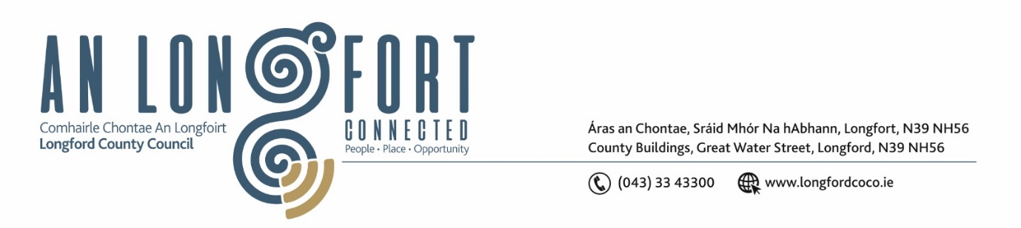

LONGFORD MUNICIPAL DISTRICT

Please note meeting will be held in the Council Chamber, Aras an Chontae and via Microsoft Teams

22 September 2022.

To: Each Member of Longford Municipal District.

Dear Member,

You are requested to attend the Meeting of Longford Municipal District to be held in the Council Chamber, Aras an Chontae and via Microsoft Teams on Wednesday 28 September 2022 at 3.30pm to transact business, as set out on the agenda hereunder.

Yours sincerely,

Ann Marie Mc Keon
_______________
Ann Marie Mc Keon
Meetings Administrator.

AGENDA

Prayer before meeting.

1. Confirmation of Minutes:
- Longford Municipal District Committee Meeting held on Tuesday 26 July 2022 – copy enclosed.
- Longford Municipal District Meeting held on Tuesday 26 July 2022 – copy enclosed.

2. Matters arising from Minutes.

3. Declaration of Interest by Members.

4. Management Report – enclosed.

5. Presentation – Community Warden.

6. Community Grant Support Scheme 2022 – to follow.
7. Notices of Motions, submitted by Councillors, as listed hereunder –

Councillor Uruemu Adejinmi
I call on Longford County Council to install a sensory room in Longford Library to make the library more inclusive for residents in Longford.
Councillor Uruemu Adejinmi
I call on Longford County Council to update road markings and signage in Farneyhoogan Estate for safety of motorists and residents.
Councillor Gerry Hagan
Following the taking in charge of the roads and lighting in this development, that Longford County Council, now take in charge the small sewerage plant that services the six houses in Radharc na Coille, Cullyfad.
I call on Longford Municipal Council to carry out a low cost safety scheme at the crossroads at Kiernans Forge. This is one of the busiest junctions with accidents occurring on a regular a basis.

